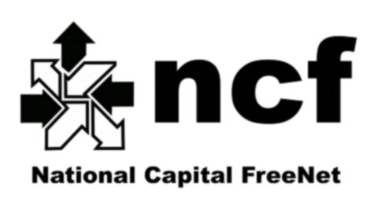

RESOLUTION OF THE BOARD OF DIRECTORS REGARDING SIGNING AUTHORITY

Resolution in writing of the Board of Directors of National Capital FreeNet Incorporated (“the Corporation”) dated the 22d day of August, 2017.
WHEREAS the Corporation is a corporation organized and operating under the laws of Canada;
WHEREAS the by-laws state that Deeds, transfers, assignments, contracts, obligations and other instruments in writing requiring execution by the Corporation may be signed by any two (2) of its officers or directors; and
WHEREAS the Board of Directors has determined that it is in the best interests of the Corporation to assign signing authority;
BE IT THEREFORE RESOLVED THAT:
- The following individuals are appointed and confirmed as signing officers for the Corporation:
  - Shelley Robinson, Executive Director;
  - Chris Cope, Chair
  - Peter Chapman, Vice Chair
  - Peter MacKinnon, Vice Chair
  - Carole Charest, Treasurer

- Any two (2) of the appointed signing officers are authorized to sign all documents and perform all actions necessary or desirable to give effect to the above resolution.

Moved: Jennifer Barrigar
Seconded: Graeme Beckett
VOTE: all in favour
RESOLUTION ADOPTED

