1st Kanata Scouts Apple Hill Fall Camp 18-20 October 2013

Risk Management Plan

Part 1 –Useful Information - Available to all including Parents

- Location: 18739 Concession 2 Road, North Glengarry, ON.
- GPS Coordinates 45.229748, –74.749947
- Driving Distance Time: 111Km – 1h20 each way approx
- Route: http://goo.gl/maps/79P2J
- Website: http://scoutdocs.ca/Camps/Camps.php?camp=applehill

Dates
- Friday 18 October (19:00) – Sunday 20 October 2013 (14:00) – official camp open/close times

Drop off / Collection Time/Location:
- Meet at Georges Vanier @ 17:00 on Friday 18 October to car pool for 17:15 departure
- Meet at Georges Vanier @ 15:30 on Sunday 20 October to collect
- Parents responsible for safe delivery/collection of scouts to/from camp

Emergency Communications:
 | Cell | * First Aid Qualified
Scouters on Camp | 613-  613-  613-  613-  613- | Jeffrey Brown – Camp Lead  Graham Birkenhead*  Dave Lee*  Keith Cunnane*  Paul Barbeau
Troop Kanata Contact for Parents (Emergency Only): | Cell: 613- | Jane Birkenhead
Camp Warden: | 613-673-2568 | Jeff Moore

Emergency numbers
Emergency: | 911
Hospital:  (Emergency department open 24/7) | 613-525-2222 | Glengarry Memorial Hospital  20260 County Road 43 Alexandria, Ontario; K0C 1A0  (See driving directions at end of document)
Poison Information | (800) 267-1373
Ambulance: | 911
Fire: | 911

* Cell phone coverage for Bell and Telus is reasonable. Rogers is unknown- assume poor.

Part 2 - Risk Management – to be read by all event participants

This is a Category 2 (BP&P Section 10000) activity and has been planned accordingly.

Information concerning the camp has been sent to parents and participants; all participants are to read Parts 1 and 2 of this document.

Key activities for which Risk considered:

Friday. Arrive at camp (officially opens at 19:00). Set up tents. Cook snack/mug-up. Briefing on camp layout/safety. Maybe camp fire.

Saturday:
- Morning: Scouts will cook breakfast in patrols
- Stove Permits: Scouts will be shown camp stove safety or tested on camp stove safety depending on their level.
- Pioneering: Staves are provided by the camp, and Scouts will practice lashing skills and knots
- Archery: Scouter to coordinate with the Camp Warden on the safe use of the archery equipment and range (consultation to happen in the morning), and Troop will be divided into appropriate sizes to cycle between Archery, Pioneering and Stove permits.
- Afternoon: Scouts will prepare lunch in patrols
- Fire permits: Scouts will gather firewood, lay and light fires under the close supervision of Scouters.
- Evening: Scouts will prepare dinner over their campfires, in patrols. Campfire and songs/skits.

Sunday:
- Morning: Have Scouts pack sleeping bags and mats _before_ breakfast.
  - Scouts will cook breakfast and prepare lunch in patrols
- Main activity: Hike / Orienteering / Geocaching / Game. Permit work if time allows.
- Scouts Own
- Afternoon: Lunch and then pack up
- Camp Closes at 14:00

Activity | Risk | Likelihood | Response
Travel to/from Site | Accident | L | Parent responsible for transporting Scouts to site. Camp officially starts at Apple Hill Scout Reserve.
 | Getting Lost | L | Google Maps Links provided to parents
General at Camp | Scouts getting lost or split up | M | All scouts are to remain within the boundary of the Apple Hill Camp Scout Reserve. In general, scouts are to remain in the immediate area of the camping area or within other defined areas. And to know how to find their way back to the Troop Camp area. All activities outside the camp area will be done as a troop (together). For these activities the troop will be broken up into patrols, with a leader assigned to each patrol. If a scout is leaving the camp area or the location of the troop for any reason the buddy system will be used. Participants will wear a whistle at all times.
 | Axes/Saws/  Knives/Mauls | M | Mauls and Axes will be used in the preparation of wood for the fires. Maul and/or axe to be used by Scouters or Scouts under supervision of a scouter – even those with Permits. Knives will be used to make shavings for fire starting; only scouts with knife permits will be allowed to use knives; knife permit work will be done if time permits.
 | Fire | M | Matches only to used under supervision.  Fires permitted only in fire pits, fire pans and/or wood stoves.  Fuel to be stored away from camp.  No cooking/lanterns in tents.  Camp activity will involve fire permit work; only scouts with fire permits will be allowed to build fires unaccompanied.
First aid | General | - | Troop First Aid Kit and designated Scouter who holds it will be identified to participants.  Scout emergency contact information and accident reporting forms carried in first aid kit.
 | Burns | M | Stove/Lanterns training will be provided. Burn FA liquid to be carried in FA Kit
 | Drowning | L | No swimming or boating activity as part of this camp.
 | Allergic Reaction | M | No peanut, kiwi or sesame seeds products will be allowed at the camp. Scouts with risk of anaphalaxis to carry Epi-Pen; leader should also carry back up Epi-pen provided by parents.
 | Sickness – Water | L | See Drinking Water
 | Sickness – Toilet Hygiene | M | KYBO on site. Hand wash will be setup outside KYBOs. Hand sanitizer will be at campsite where food is prepared/served. For day trips bathrooms/outhouses if available will be used. If nothing close by when needed the woods will be used. Hand sanitizer will be taken on day trips.
 | Sickness – General | L | If seriously ill, arrangements will be made to take casualty to hospital. If not seriously ill parents will be contacted for return home  See: Response to Accident/emergency
 | Hypothermia | L | Scouts will be sleeping outside in tents; all will have sleeping bags suitable for spring/fall camping.  Extra sleeping bags will be taken by the leaders in case someone’s bag is not adequate.
Drinking water | Availability and Potability | L | There is no potable water available at the camp site. Potable water will be transported from Kanata.
Equipment Failure/  Damage | Camping Equipment | L | Spares kit carried (duct tape etc.).
 | Canoes | N/A | N/A
Wildlife | Bears | M | Food to be stored in vehicles overnight or when camp is unattended. ABSOLUTELY no food/toothpaste in tents.
 | Raccoons/Skunks etc. | M
 | Stinging/Biting Insects | L | Participants to use bug repellant and ‘afterbite’. Afterbite and antiseptic/soothing cream (eg Lanocaine) to be carried in First-Aid Kit.  Also, See Allergies  NB: DEET will damage technical camping/hiking equipment. Mitigation is to use only Cream DEET (ie non-spray) – Cream DEET will be provided by Troop. Hands are to be washed/rinsed after applying Cream DEET.
 | Ticks | L | Ticks have not been reported at Apple Hill. However, all participants are to check themselves regularly during the camp and for several days upon returning from camp.
 | Poisonous plants – eg Poison Ivy | L | There may be Poison Ivy in the Camp area. All participants taught to recognize Poison Ivy – and avoid. Immediate action is to remove source – ie clothing to prevent recontamination. ASAP (within minutes if poss), wash then rinse thoroughly using detergent soap (sunlight is best!) also calamine lotion and sodium based soothing, cooling, anti-itch cream; hydrocortisone cream. Poison Ivy causes allergic reaction – see First-Aid / Allergies.
Food | Nut and Other Allergies | L | Participating Scouts with nut and dairy allergies attending camp. Meals & Snacks to be nut free.  See First-Aid / Allergies.  All food should be peanut/nut free; however, participants with allergies and intolerances should make other group members aware.  Menu planners should plan around known allergies and intolerances.
 | Spoilage - Safe Storage | L | ALL food to be stored in cars. Temperatures may be warm and so perishable food should be kept in a cooler with Ice Packs.
Water Activities | Safety | L | Any water will be off limits.
Orienteering/Hike | Getting lost or separated | L | On the hikes all participants must stay on the marked path or identified route. The troop will travel together or in designated teams. All participants are to carry whistles and know the emergency signal / protocol.
 | Injury – travelling over uneven ground | M | Walking or running over uneven ground carries the risk of trip or twist injuries. Scouts are to be briefed on the danger. Good footwear will reduce risk. All scouts to move around in teams (of at least 2). All to carry whistle and know how to call for help.
Archery | Arrows | M | Scouter has been appointed Range Officer; as such, his word on all matters regarding range use is final. All participants are to be fully briefed before using the range. All bows are to be placed on the ground before anyone steps in front of the firing line. Bows may only be picked up on the explicit direction of the range officer or his nominated deputy.

Directions to Apple Hill Scout Reserve from Ottawa:

- Take Highway 417 E
- Exit at Highway 138 (Exit # 51)
- Take Highway 138 south to traffic lights; turn left into Monkland
- Take Highway 43 east
- Turn right into Apple Hill
- In Apple Hill, turn left onto Hughie Munro Street (Kenyon Concession 2)
- Camp is on the left at about 3 km

Communication Plan should an Emergency Situation Arise:

Preparation:

- On arrival, check your phone to find where cell coverage is good.

- Ensure one car is kept available as an emergency evacuation vehicle.

Should an emergency arise:

- Assess, treat and/or evacuate / organize extraction depending on nature of incident/injury – see driving instructions below.

- Advise CAMP RANGER immediately of any emergency situation, if present. If not present, contact the person in charge (see list in Camp Bunk).

- As soon as possible call one of the Rangers and/or warden and advise of situation. Is their presence required?

- Complete incident report form as required by Scouts Canada and submit as per instructions on form. Please advise Camp Warden by phone or e-mail ASAP.

Closest Hospital/Emergency Facilites - Hospital in Alexandria:

One vehicle to be kept on site to use as a medical evacuation vehicle.
See attached map with driving route to Alexandria Hospital

From Northwest entrance of Camp:
- Exit camp property; turn right on Kenyon Concession 3
- Turn left onto Boy Scout Road
- Follow to Highway 43 (300 metres)
- Turn right on Highway 43
- Follow to entrance to Hospital (on your right just after entering the town of Alexandria (8Km)

From Northeast entrance of Camp:
- Exit camp property
- Go straight ahead onto Boy Scout Road
- Follow to Highway 43 (300 metres)
- Turn right on Highway 43
- Follow to entrance to Hospital (on your right just after entering the town of Alexandria – approximately 8 kilometres)
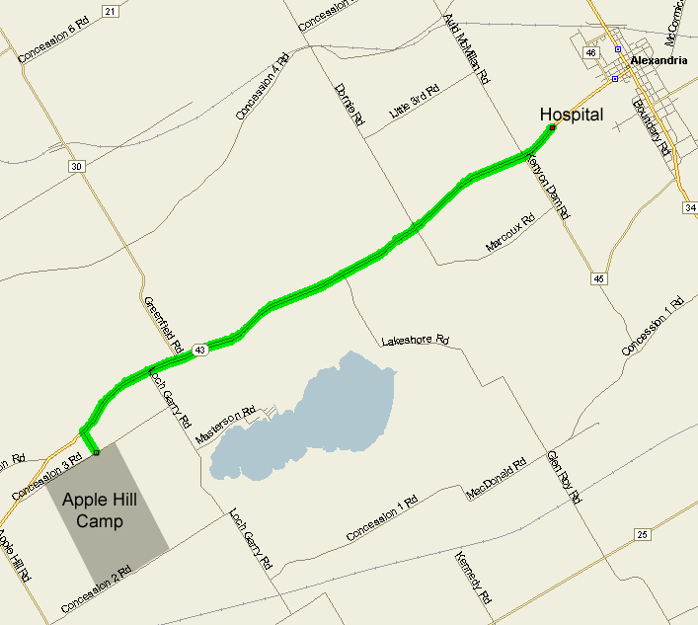

Y – Check Personal Detail sheets for full details

Registered: | Yr | Parents | Prime Phone | Sec Phone | Diet | Allergy | Other | NOTES

Y – Check Personal Detail sheets for full details

 |  |  | Who is at home if we need to contact them
Leaders: | First Aid | Cell Phone @ Camp | Contact | Contact Phone | Diet | Allergy | Other | NOTES

